**Managerial Report Ocean View Development Corporation.**

Akshay Appani

Trine University

12/3/2023

**1**

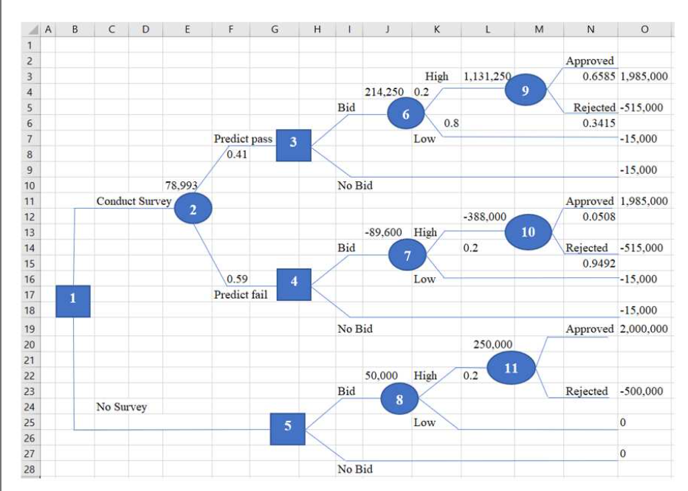

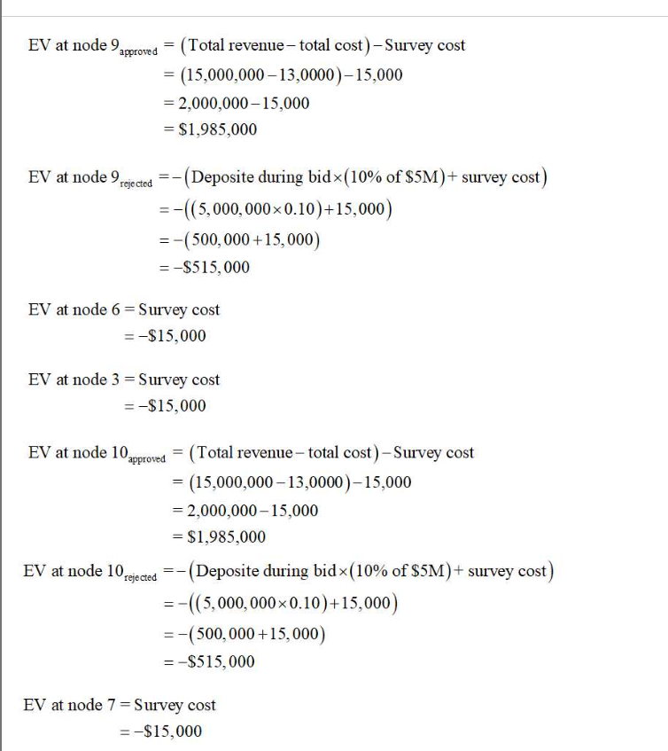

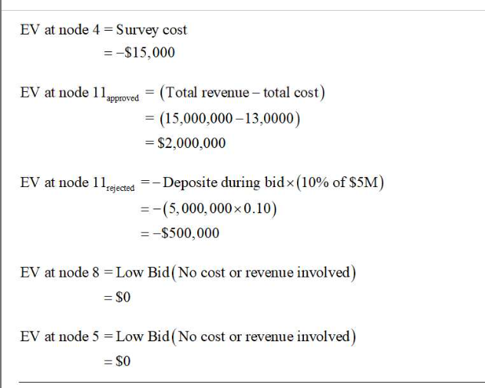

**2**

The fifth node highlights the hindrance of ODC due to insufficient market research data. As ODC made a decision at this point without extending an offer, there are no financial consequences or advantages for them. Nevertheless, a project with a value of $5,000,000 has a mere 20% probability of getting approved. If the plan is granted, there is a 30% probability that condominiums would be allowed in the zone. Failure to adopt the proposed zoning modifications would result in ODC forfeiting the $500,000 it initially deposited.

***Projected values:***

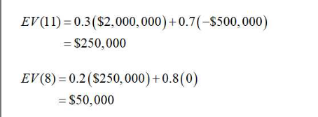

The suggested approach is suitable for adoption due to its significant anticipated utility. Nevertheless, if voters determine that the zoning change should not be implemented, it is probable that the deposit will be forfeited.

**3**

***Bid if pass:***

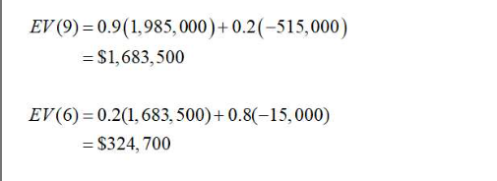

***Bid if fail:***

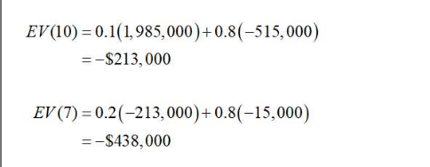

If the market research indicates that the zoning change would be successful, the property could be listed for sale. If the market assessment indicates that the planned zoning laws would not be applicable, it would be imprudent to proceed with the project.

4.

ODC may determine the employment of a market research company by comparing the anticipated bid value with and without the survey. This disparity underscores the significance of the market survey data. If the anticipated value of the data is lower than the cost, it would be illogical for ODC to engage the services of the market research business.

***Calculation:***

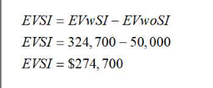

The anticipated benefits derived from investing in market research are sometimes denoted as "EVSI," which stands for Expected Value of Perfect Information. The survey method's anticipated value is shown by the "EVWSI" in comparison to other choices. The acronym "EVwOSI" refers to the estimated value of a bid that does not take into account market research data in the study of potential outcomes.

Our team estimates that the cost of purchasing data for market research will be around $274,700. The acquired information does not justify the expenditure involved. Consequently, we advise against ODC using the services of the market research organization.

**Appendix.**

The primary objectives of the research commissioned by Ocean View Development Corporation (ODC) were to conduct a management study and do due diligence for the purpose of bidding on a parcel of beachfront property. The objective of the research is to assist ODC in determining whether or not to submit a bid for the property by carefully evaluating the advantages and disadvantages of doing so.

The report starts with a decision tree that delineates the advantages and disadvantages of each feasible course of action. The nodes of the decision tree symbolize several potential outcomes, including significant changes in zoning restrictions and the presence or absence of market research data. The anticipated yields for each alternative are thereafter computed based on the probability of the several scenarios outlined in the report's concluding section.

The study strongly indicates that ODC should continue to submit offers for the property based on the anticipated value of the option, even in the lack of market research data (Blankespoor et al., 2020). The paper emphasizes the need of considering potential zoning limitations and the potential consequence of forfeiting the deposit if this course of action is selected.

The viability of engaging a market research firm to collect further data on the anticipated ramifications of the zoning ordinance adjustment is also assessed. The article arrives at this conclusion by evaluating the anticipated value of the strategy, both with and without the survey data. Upon conducting their analysis, the authors of the article discover that the expense associated with data collection for market research surpasses the worth of the data acquired. Consequently, the article dissuades its readers from using market research businesses.